**Nepal’s Out Migration and Agricultural Output: An Agricultural Study from Chitwan Valley**

by Grace Kay and Sadikshya Nepal

**Background**

The small agricultural country of Nepal has become a huge exporter of human labor in recent years. Nepal’s internal struggle with poverty, political instability, corruption, and environmental degradation has forced thousands of people to seek employment in foreign countries. While migration to India has been a recurring phenomenon for centuries, migration to the Gulf States, Europe, and the USA began just over 15 years ago.[1] For example, according to the Pew Research Center “Nepal’s GDP in 2016 was just $21.1 billion, ranking it 96th in the world by purchasing power parity”. Of the 1.6 million Nepali who are living in countries outside of Nepal, the remittance sent back is estimated by the World Bank account for 30% of Nepal’s GDP. Migrants to Qatar, Saudi Arabia, India, and the United Arab Emirates are some of the countries with the highest number of Nepali diasporas.[2]

In the journal, *New Figures for Old Stories: Migration and Remittance in Nepal*, scholars contend that Nepal migration data has insufficient statistics, so the scale and significance of this phenomenon is still unknown.However, there is an under reporting of data, because everybody that leaves the country is not always accounted for due to illegal crossing, or possible inaccuracies in the census. Real numbers from migration data suggest that reported statistics are actually much lower than the number of people leaving the country.[3] 85% of Nepal’s economy relies on subsistence agriculture in rural areas[4] while 66% of people are directly engaged in farming, accounting for 34% of the GDP 5,6. Rice, Millet, Buckwheat are considered to be major food crops. Improving agricultural production has become important to uplifting the standard of living of the Nepali people, due to Nepali people's high dependency on the agricultural sector. [5] Nepal’s agricultural practice depends heavily on subsistence farming. Peasant farmers rely on human labor for agriculture production and only use conventional farming techniques. We content that out-migration from Nepali’ agricultural labor force and more exits from the agricultural sector would be a huge loss for productivity in agriculture. Many people are excited to exit the agricultural field,and are eager to find lucrative employment in urban areas and abroad. Yagya Raj Joshi, senior agricultural development officer illustrates this point when he stated that “*People are leaving land fallow where crops worth gold and silver can grow, to work as laborers making 10,000 to 12,000 rupees [$115-$139] a month*.” [6]  
**Literature Review**

As more people are moving from their places of origin, especially in developing countries that rely on agriculture, it is important to research how this phenomenon will effect the origin country and its agricultural production. Migration has become much easier with globalization, and with global inequality more people from developing countries are moving abroad for better economic opportunities. Nepal is a prime example of this. Researching the effect on migration on agricultural production will continue to be important because most people leaving the agricultural sector are from developing countries, and most developing countries are dependent on agriculture. These patterns can inform policy making decisions in the future.

Theories among migration and agricultural production are not straightforward. While many theories exist as to why people migrate, the economic reasons are considered to be the most significant factor for why people decide to move.[7] Beyond the push and pull factor in migration, there are multiple other underlying factors that work to make this relationship a complicated one. Since “outmigration, particularly from developing countries, is quite significant and the contribution of rural households in supplying migrants is increasing”[8] we wanted to look at existing literature that would help explain some of the other underlying phenomenon working to drive this occurrence. Literature suggests that besides migration, some of the other factors that could affect agricultural productivity is technology, considering migration and technology together can produce a conflicting hypothesis.[9] On the one side, the hypothesis states migration is beneficial for the origin country because remittance is sent back and spent technological changes in agriculture resulting in higher production. On the other end of the spectrum, the negative impact of migration asserts that the decline in labor and human capital adversely affects the output of the native place.[10] The influences of migration on agriculture productivity in migrant-sending-households are complex and ambiguous.

**Research Question**

With Nepal’s dependency on manual labor for agricultural production and its increasing migratory trend, we want to investigate whether this outflow of working

Nepali men and women outside of Nepal has had consequences (positive or negative) in the agricultural sector. We want to examine if out-migration has had any impact on various crop production in Chitwan Valley, a southern region in Nepal with fertile land and high agricultural output in order to make a general inference about the status of out – migration and agricultural production in the entire country. Furthermore, we also wanted to see if outmigration and agriculture output was in any way related to caste difference, which is prevalent in Nepali society.

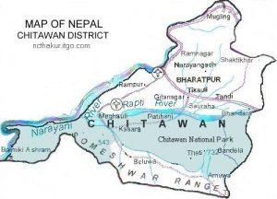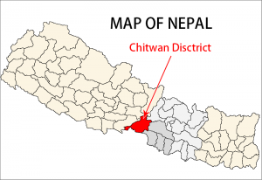

**Data Source**

The data for this research project comes from two locations.

1. The first data that was collected comes from the World Bank remittance report. The report is an excel file that shows remittance received by each country globally from 1970 to 2018. The World Bank estimates remittance flows globally and bilaterally based “on national balance of payments statistics produced by the central banks and compiled by the IMF.”[11] The World Bank estimates are large datasets covering most countries around the world, from which we isolated the research statistics for Nepal for the purpose of this research question. However, it is important to note that these estimates are far from accurate due to methodological challenges, and only provides a general idea of the remittance trend for the country. Moreover, when comparing remittances across time, it is necessary to realize that the growth in remittances may have come from changes in how remittances are calculated. Lastly, we need realize that the remittance calculated in the World Bank Statistics only considers remittance transferred through established channels, such as banks, and does not account for all money transfers via Western Union, post office, informal exchange, etc.[12]
2. Our second data set comes from the Chitwan Valley Family Study (CVFS): Labor Out-Migration, Agricultural Productivity, and Food Security as part of the Program in Society, Population, and Environment from the Institute for Social Research at the University of Michigan. The data-set that we used to conduct this research looks at “household agriculture and Migration Survey that includes information on household agricultural practices and remittances received by each household.”[13] Topics of the survey include “crop production and farm technology use, wealth, assets, income, consumption, food insecurity, and information about each household member who is currently away from home. The survey also collected information on gender, ethnicity, and age.”[14]

**Variables**

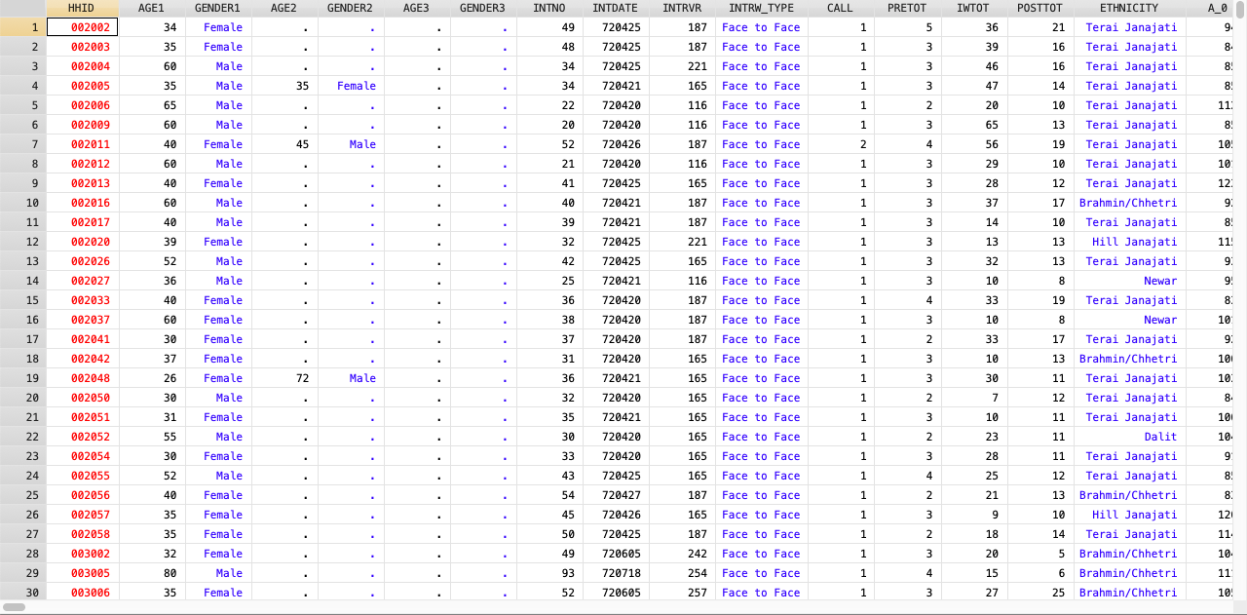

Example of how the data was received

Codebook is shown below

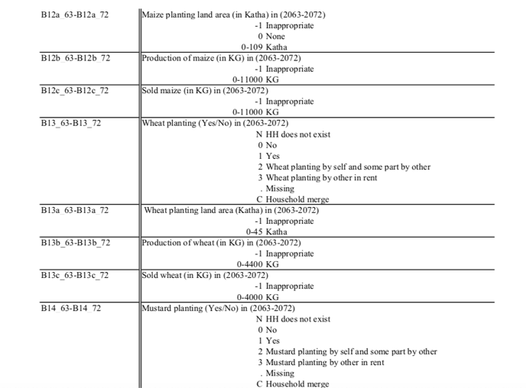The variables we wanted to investigate for the purpose of this research were the agricultural crops that are generally produced in the Chitwan Valley. Of the ten years that this data was collected, we looked at production rate, the number of

migrants that have left each household, and the remittances received by each family. We wanted to see whether the agriculture production in the area would increase

or decrease? Therefore, the **dependent variables** we were looking at were *total production of crops*, which we calculated by tallying all the crops produced in Chitwan Valley. Additionally, we wanted to see to what degree migration and remittance

affects individual crops that are mostly produced in the area. Some of other dependent variables included- *rice, wheat, mustard, and buckwheat*. By looking at individual dependent variables of specific crops, we were curious to investigate which crop was affected the most. Since we were looking at the effect of *Migration and Remittance*, our **independent variables** were *Migration and Remittance*. However, we wanted to **control** for *ethnicity* to see if migration, remittance and ethnicity impacted crop production at all.

**Methodology**

Our methodology can be explained using the do-file which was created in Stata using CVFS data. Because the data file from CVFS was incredibly large, we only kept the variables that we needed to use for our research question. The code is in black and the methodology will be explained in blue between each step in the do-file below.

**Project 1**

|  |  |
| --- | --- |
|  | **use "/Users/gracekay/Desktop/final project/CMS Data- FULL Variable.dta"**  ***Data pulled from CVFS with variables needed for our research*** |
|  | **keep MIG* A1_* A2_* A2A1_* A3_* A9_* B11_* B11A_* B11B_* B11C_* B13_* B13A_* B13B_* B13C_* B17_1_* B17_1A_* B17_1B_* REM* HHID** |
|  | ***Variables kept for research question are***  **MIG= Number of migrants**  **A1_= Farming (Yes/No)**  **A2_= Land area used for crop cultivation**  **A2A1_= Other's land area used for crop cultivation for free**  **A3_= Land area rented out (in Katha)**  **A9_= Bought new house plot (Yes/No)**  **B11_= Bought new house plot (Yes/No)**  **B11A_= Rice planting land area (in Katha)**  **B11B_= Production of rice (in KG)**  **B11C_= Sold rice (in KG)**  **B13_= Wheat planting (Yes/No)**  **B13A_= Wheat planting land area (Katha)**  **B13B_= Production of wheat (in KG)**  **B13C_= Sold wheat (in KG)**  **B17_1_= Buckwheat planting (Yes/No)**  **B17_1A_= Buckwheat planting land area (in Katha)**  **B17_1B_= Sold buckwheat (in Rupees)**  **C18_= Total tractor use in Minutes**  **REM= Remittance received in rupees**  **ETHNICITY= ethnicity of each household**  **HHID= Household Identificaiton**  **Reshape long MIG A1_ A2_ A2A1_ A3_ A9_ B11_ B11A_ B11B_ B11C_ B13_ B13A_ B13B_ B13C_ B17_1_ B17_1A_ B17_1B_ REM, i(HHID) j(year)**  ***All Variables were moved from column to row according to year and household number, so that we could calculate total production across years*** |
|  | **foreach x of varlist A* B* MIG REM {** |
|  | **recode `x' (999=.)**  ***Removes households that did not exist, which is code 999*** |
|  | **recode `x' (998=.)** |
|  | **}**  ***Drop missing values for when two households combine and a missing value is created*** |
|  | **recode B11_ (2=1)**  ***Recoded variables so a yes answer =1 and a no answer = 0.***  ***B11 stand for rice production in the data set.***  ***B11 also had households who rented the land out for planting.*** |
|  | **recode B11_ (3=1)**  ***Recoded variables so renting out land for farming is still counted as a yes (1) for farming.*** |
|  | **replace A2_ = A2_/11.97295** |
|  | **replace A2A1_= A2A1_/11.97295** |
|  | **replace A3_ = A3_/11.97295**  ***Replaced Old Variable with New Measurements to change the Nepali land measurement in Katha to the U.S. measurement of acre.*** |
|  | **replace B11A_ = B11A_/11.97295** |
|  | **replace B13A_= B13A_/11.97295** |
|  | **replace B17_1A=B17_1A/11.97295**  ***We wanted to look at total production and in order to look at total production, we will look at the (production of the crop (wheat or rice)/total land that was used for production)= total proportion of production (for wheat and rice).*** |
|  | **regress A1_ MIG if A1_==1| A1_==0**  ***Regress Farming (Yes/No) on Migration*** |
|  | **generate self_cult= A2_- A3_** |
|  | **generate wheat_prod= B13B_/B13A_** |
|  | **generate rice_prod= B11B_/B11A_** |
|  | **generate buck_prod= B17_1B/B17_1A**  ***Generated each crop production by calculating reported production of crops over total land the crops were produced on.***  **gen logincome= log(REM)**  ***Generated log value for the Remittance received*** |
|  | **\*collapse (sum) A2_ A2A1_ A3_ B11_ B11A_ B11B_ B11C_ B13_ B13A_ B13B_ B13C_ B17_1_ B17_1A_ B17_1B_ MIG REM, by(year)** |
|  | **generate total_production= B11B_+ B13B_** |
|  | ***regress total_production MIG REM C18_***  ***Regress Migration on total production using migration, remittance, and tractor use***  ***regress total_production MIG REM C18_ i.ETHNICITY***  ***regress rice_prod MIG REM i.ETHNICITY***  ***Generate rice production due to Migration based on Ethnicity*** |
|  | **regress total_production MIG REM C18_**  ***Regress Migration on total production using migration, remittance, and tractor use***  **regress total_production MIG REM C18_ i.ETHNICITY**  **regress rice_prod MIG REM i.ETHNICITY**  ***Generate rice production due to Migration based on Ethnicity*** |

**Project 2**

**use "/Users/sadikshyanepal/Desktop/Data Management /CMS Research /36755-0001-Data.dta"**

***Data pulled from CVFS with variables needed for our research***

**collapse (sum) REM63 REM64 REM65 REM66 REM67 REM68 REM69 REM70 REM71 REM72**

***Generate total remittance across 10 years***

**gen x= _n**

**reshape long REM, i(x) j(year)**

***Reshape remittance from columns to rows according to year***

**gen REM_lag=REM[_n-1]**

**gen percent = (REM-REM_lag)/REM_lag**

***Code to generate national and regional remittance in percentages***

**replace year = 2007 if year== 63**

**replace year = 2008 if year== 64**

**replace year = 2009 if year== 65**

**replace year = 2010 if year== 66**

**replace year = 2011 if year== 67**

**replace year = 2012 if year== 68**

**replace year = 2013 if year== 69**

**replace year = 2014 if year== 70**

**replace year = 2015 if year== 71**

**replace year = 2016 if year== 72**

***Replace years from Nepali calendar to Gregorian Calendar or AD***

**merge 1:1 x Year using `ABC'**

**keep if _merge==3**

**export excel using "/Users/sadikshyanepal/Desktop/Data Management /Percentage Change.xlsx", firstrow(variables), replace**

***Chitwan Valley remittance and national remittance was merged based on year***

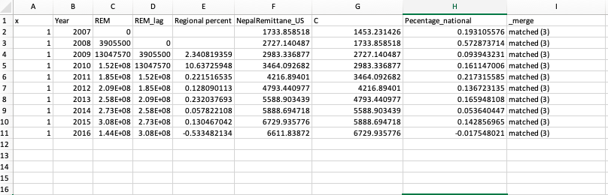

**Results**

Looking at the remittance percentage change value over each year, the national percent change increases each year, but the percent changes in the Chitwan Valley is a lot smaller. It means that as nationally the percent of remittance received increases each year, the percent change in the valley itself does not show a significant amount of percent increase in the remittance value received.

We first generated total production of crops by calculating the complete amount of crops that were produced for all 10 years (2007-2016). We took the data that was reported as production by each household across every day. Then, by using Migration and Remittance as our independent variable we got the following regression result.

**Y (total production)= *ɑ+β1(Migration)+β2(Remittance)***

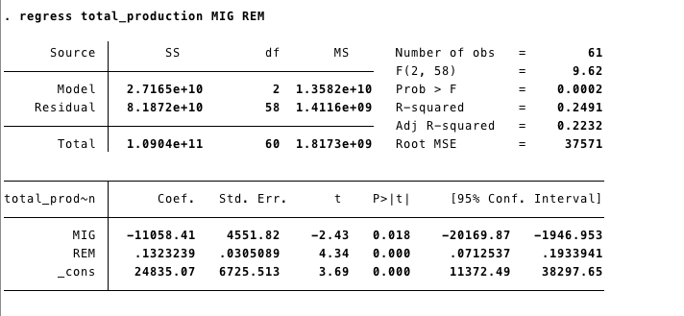

According to the result, we see that migration has a negative impact on total production of crops, whereas remittance has a positive impact. Both the variables are significant and explains about 25% of variability in our y-variable- total production, as seen by R-Squared=0.249. It shows that for every one person leaving the household total production decreases by around 12,000 KG for a 10 year period. For a small peasant farmer that is dependant farming, that is a significant decline in production for a decade. While migration shows a significant impact, REM also denotes a significant impact (calculated in rupees to be significant). For every 1 rupee the family receives (100 rupees= 1$US) production increases by .1323 KGs. All these factors have significant impact, explaining 24% of variation in our data.

We also wanted to see what would happen if were to put the use of technology as an independent variable. Based on other labor study to come out of CVFS by Prem Bhandari and Digha Ghimira, who states the use of tractor on increased agricultural output,[15] we wanted to test the use of tractor (C18_) in our result. The model used is shown below:

**Y (total production)= *ɑ+β1(Migration)+β2(Remittance)+β3(Tractor Use)***

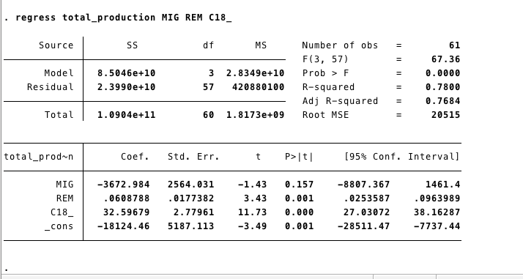

Here we see that the total use of tractor calculated in minutes makes the migration study insignificant, but shows a positive impact between remittance and tractor use. This helps us deduce that with both remittance and minutes of tractor use gives a significant result and a positive impact. It’s possible that the families receiving remittance are perhaps also incorporating more technology in their agricultural practices.

Lastly, we wanted to use the Ethnicity as a control variable to see if migration, remittance, and technology has any effect on certain caste in Nepal as the caste system truly dictate your upward mobility. The model used is shown below:

**Y (total production)= *ɑ+β1(Migration)+β2(Remittance)+β3(Tractor Use)+β4(Ethnicity)***

*Hill Janjati= Hill Indigenous (more elite)*

*Tara Janjati= People from the plains*

*Dalit= Untouchables*

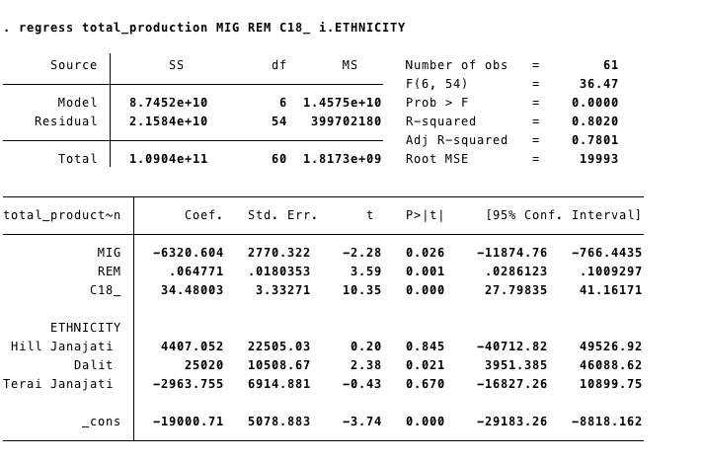

As you can see in the result above, migration and remittance does have a significant positive impact on the Dalit population. This is possible because the untouchables have a significantly more difficult time conducting labor in Nepal, so migration and remittance do impact their livelihood.

We understand that the standard error in the migration value is very high. We did attempt to calculate that based on the log value of migration; however, using log value resulted in higher standard error. For that reason, we decided to go with the regular migration numbers.

While most of the results above were calculated after adding total production over the 10 year period, we also wanted to see how Migration, Remittance, Technology, along with Ethnicity impacted production on a household basis. For that, we ran several tests at a household level looking at production of individual crops, and its production level based on a household level. After converting land calculation from katha to acres, we ran each production in Kgs/acre and looked at the production level. We found that the only significant change in individual crops at a household level was rice. That is understandable, because rice is the most common grain produced in Nepal. However, what was surprising was that mustard, which is the most popular crop of the region, did not yield any significant results. However, these independent variables also only reflect 1% of variation in our y-variable- rice production. Models used are shown below:

**Y (rice_production)= *ɑ+β1(Migration)+β2(Remittance)***

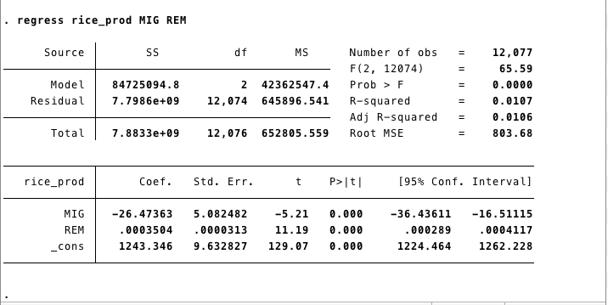

**Y (must_production)= *ɑ+β1(Migration)+β2(Remittance)***

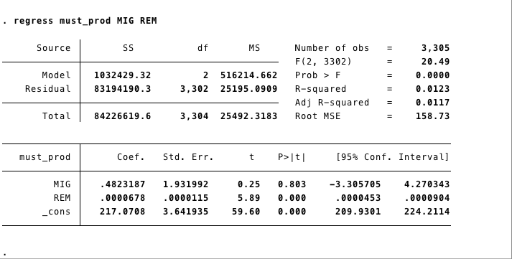

**Y (rice_production)= *ɑ+β1(Migration)+β2(Remittance)+β3(Tractor Use)***

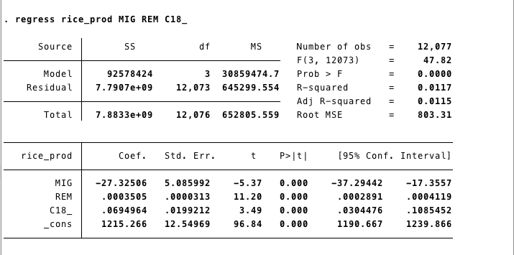

We calculated the results for each crop, however, rice production was the only crop with significant results. Please see other results in the Appendix section of the paper.

**Limitations**

This study has several limitations. Due to the conflicting nature of the theory behind migration and agriculture, it is sometimes hard to establish if migration leads to low productivity or if low productivity leads to migration. While we looked at total production produced that was reported by the family, that does not help us explain proportional production that was produced. It is necessary to calculate at how much the family produced based on the land they were producing on in order to find the proportional production. When proportional production is calculated most of our result had a insignificant results. Therefore, we were unable to calculate the production based on the land people owned. Also, our study was conducted in one region, the Chitwan Valley, which is fertile and of high agricultural production. This is not an accurate representation of all agricultural land in Nepal. Therefore, we are making larger nationwide inference, which is a limitation of our study. We could not validate the study based on the residuals of the predicted value, since we are beginners in programming also did not have enough skill to use it.

**Validity**

All the interviews conducted by CVFS are recorded and publicly available for validation. The method of the study is well documented and coding and codebook with frequencies are available online. Also, the data sources are panel studies and are open to the public and reputable. It has also been cited in many other studies about Nepal, migration, and agriculture, which adds validity to the study that we conducted.

Literature coming out of the CVFS study also suggests that the influences of migration on agriculture productivity in migrant-sending-households are complex and ambiguous, which correlates with our research. Our study speaks to our literature review that besides migration and remittance, other factors such as technology, caste and ethnicity also plays a factor in increasing or decreasing agricultural productivity of a region.

**Replication**

The research we did would be able to be replicated. All data is available on a public platform, including transcripts of each interview. Our coding is stored with instructions, which we can provide for anyone who wants to reproduce the study. All our coding and storage done with software backed up online.

**Conclusion**

We did find that total production decreases in the Chitwan valley over the period of 10 years with migration. However, when accounting for remittance the total production increases. Both tests were statistically significant with an R-squared= 0.249. This is in line with our hypothesis that remittance sent back could possibly be used to improve agricultural production with buying of technology and hiring rented help. When measuring household migration and remittance with individual crops, we see that only rice production yield significant result and show how with increase in migration rice production decreases.

**Appendix**

**Data Management**

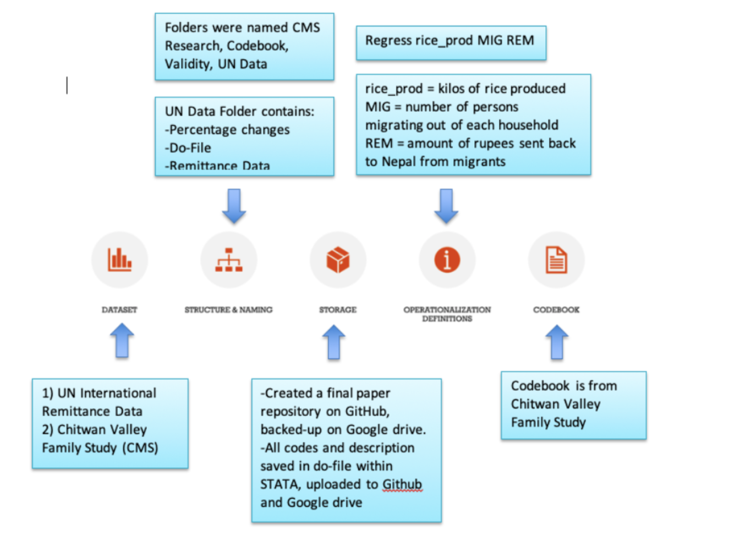

**Data Set**

The first data collected comes from the World Bank remittance report. The report is an excel file that shows remittance received by each country globally from 1970 to 2018. The second data set comes from the Chitwan Valley Family Study (CVFS): Labor Out Migration, Agricultural Productivity, and Food Security as part of the Program in Society, Population, and Environment from the Institute for Social Research at the University of Michigan. The data-set that we used to conduct this research looks at “household agriculture and Migration Survey that includes information on household agricultural practices and remittances received by the household.”[16]

**Structure and Naming**

Each folder was structured based on where the data originated from. The World Bank data was stored under a UN folder called UN_FINAL_Data and the CVFS was stored under the CVFS Research folder. Each folder was then sub-divided based on the coding and calculation that was performed on each dataset. For Example, the Codebook and Validity folder was stored separately. The dataset was updated with different name every time a new dataset was created. For example, the raw dataset received from CVFS was named “CVFS data_Full Variable”, because it contained all the variable collected by the study. When the summation of production was calculated and stored, the file was renamed “CVFS Data_SUM” to signify that the dataset only contains variables that we needed for our research. The main codebook was named “CMS codebook” and each do-file was named according to its corresponding project. For example, for Project 1. the do-file was named “Do-File for Statistical Analysis”. It consisted of all the codes used and stored for the project. The do-file used the calculations on national and regional percentage change difference was named “Percentage Do file.” This way each file is named to clearly reflect what purpose it was created to serve.

**Storage**

This research was a collaborative effort, so in order to work cohesively on the project together, we created a repository on Github back up by Google Drive. Stata was used to run regressions, and do-files from Stata are added to Github and google drive. We primarily worked on our project on Google Drive since we needed to collaborate and access document together. However, all final documents were added on to GitHub.

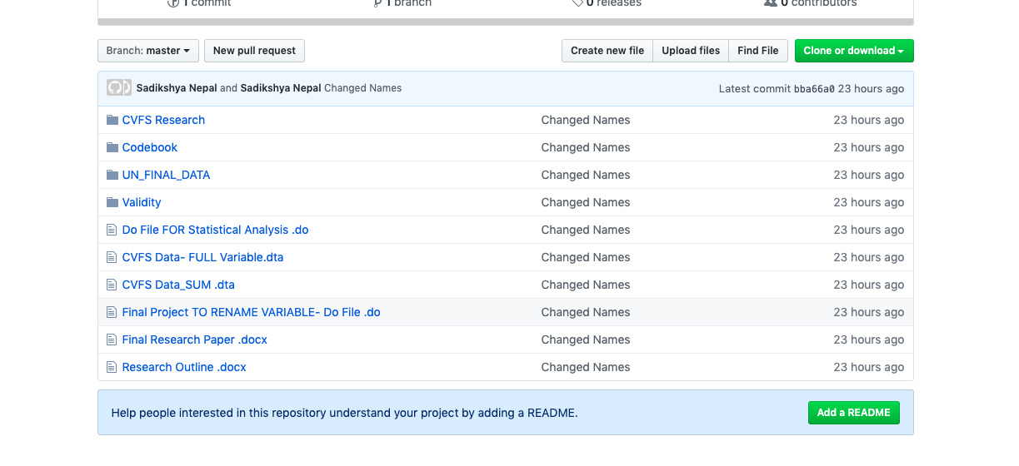

**Operationalized Definitions**

As stated in the do-file above, each variable meaning was explained.

**Codebook**

The codebook is from Chitwan Valley Family Study (CVFS). All variable meanings are explained. An example is shown below. We also created new codebooks for each generated variables and that is saved as a word doc with the title ***Created Variable Codebook.***

An example from codebook is shown below:

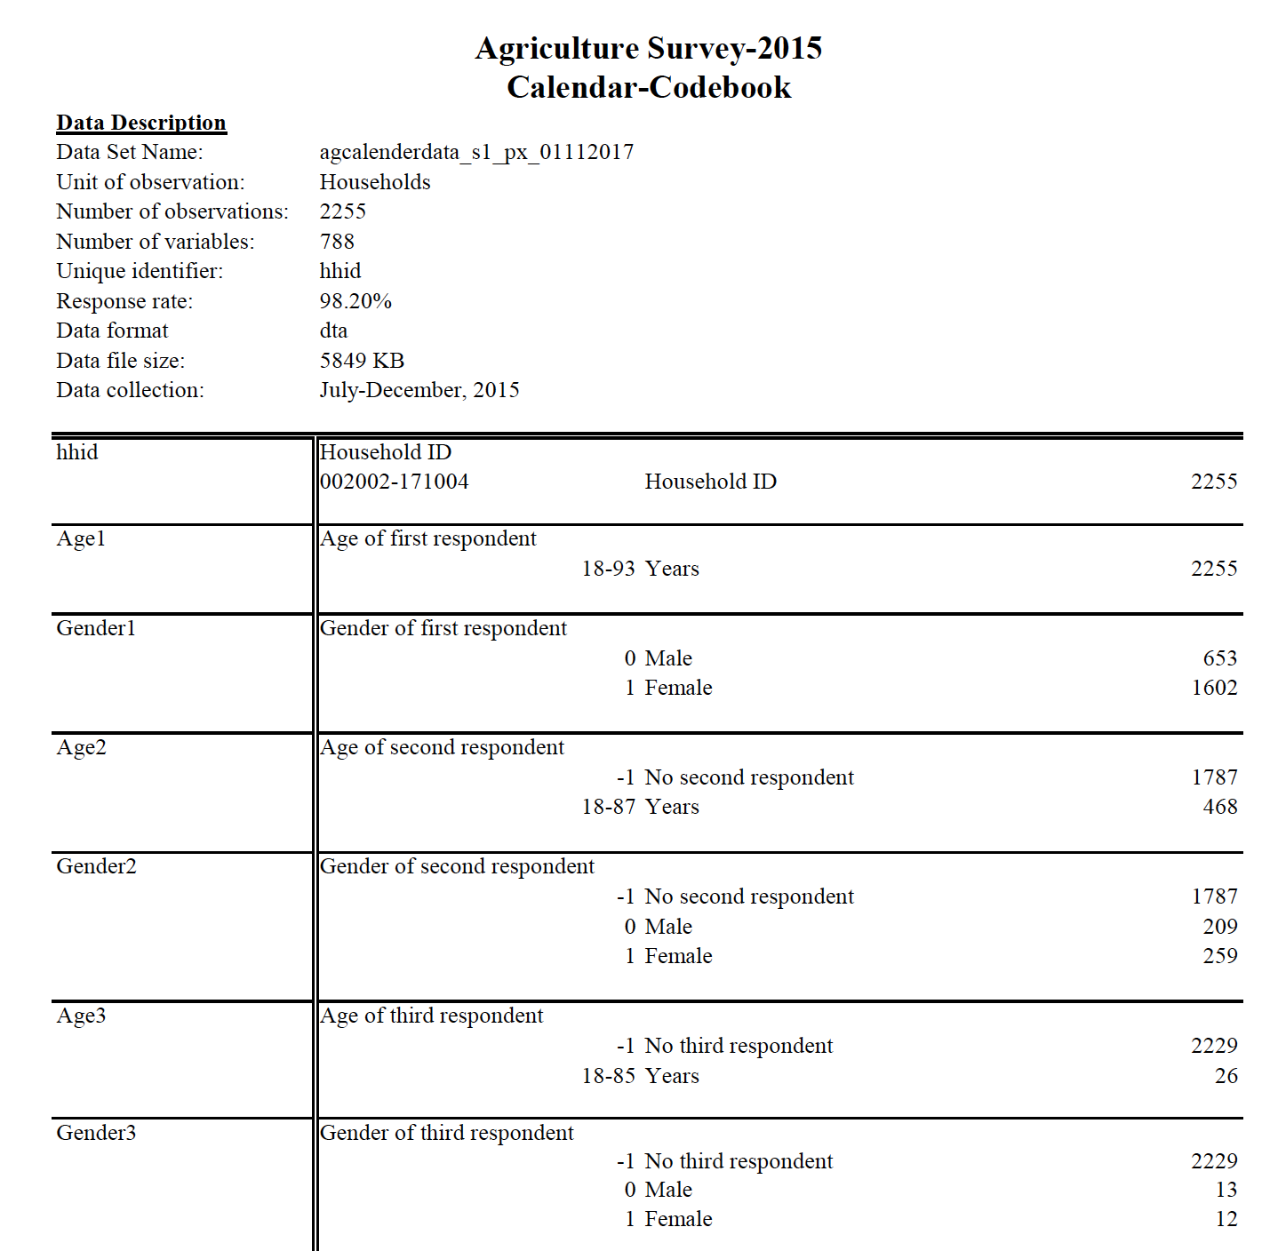

**Workflow**

Our workflow is depicted in the figure below. 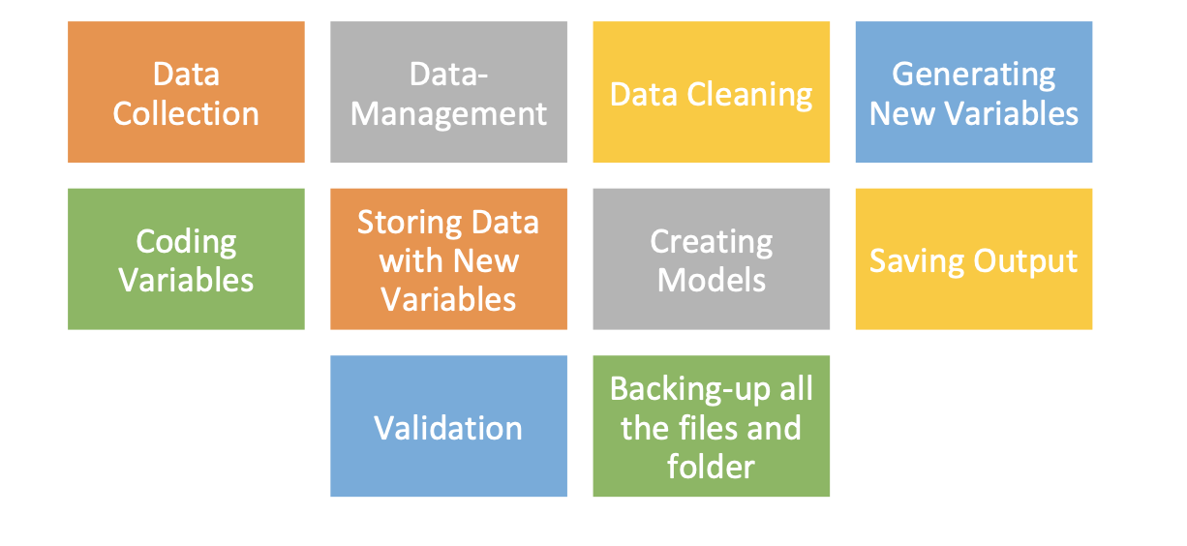

After data was collected from the World Back and CVFS, the data was cleaned, so that missing variables were dropped. After cleaning the data, we re-coded variables to account for all persons. For example, farmers who rented out their land were counted as a yes for farming that year, when before they would have been counted as a no and could have skewed the data. After new variables are created, they were used to calculate total production. We created a model using these variables. Using stata, we ran regression on various independent variables. After, our significant results were validated as stated in the Validity section of this paper. Finally, all files were uploaded to Github and backed up by Google Drive.

**Results Regressions**

***Rice Production on a Household Level***

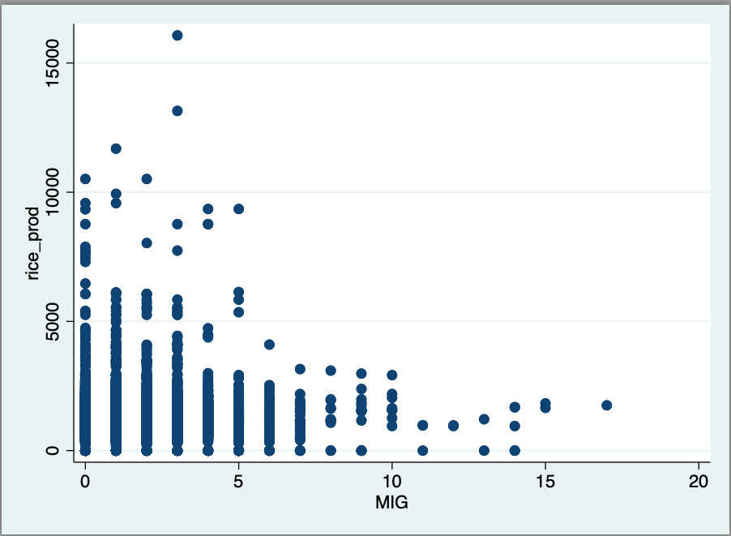

***Correlation between Rice Production and Migration on a Household Level.***

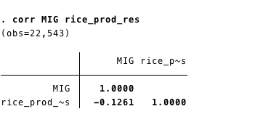

***Correlation between Total Production, Migration, Remittance, and Tractor Use.***

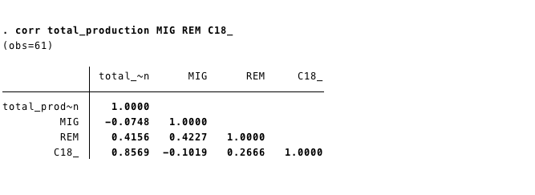

***Wheat production at a Household level. The result was not significant***

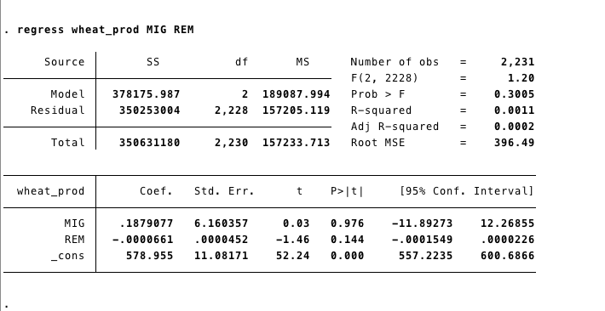

***Buckwheat production at a Household level. The result was not significant***

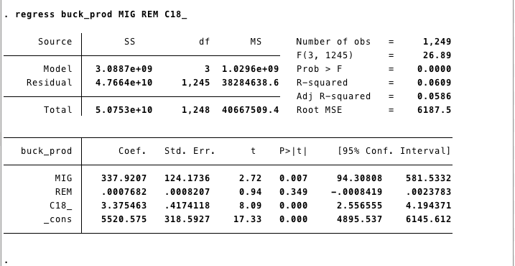

1. Kollmair, M; Manandhar, S; Subedi, B; Thieme , S (2006). New figures for old stories: migration and remittances in Nepal. Migration Letters, 3(2):151-160, page 152
2. http://www.pewresearch.org/fact-tank/2018/01/29/remittances-from-abroad-are-major-economic-assets-for-some-developing-countries/
3. Kollmair, M; Manandhar, S; Subedi, B; Thieme , S (2006). New figures for old stories: migration and remittances in Nepal. Migration Letters, 3(2):151-160, page 1.
4. ibid
5. Gauchan, Devendra, Agricultural Development in Nepal: Contribution to Economic Growth, Food Security and Poverty, December 2007
6. <http://www.thenewhumanitarian.org/report/97321/analysis-trouble-nepal%E2%80%99s-agriculture>
7. Singh, K.M, Jha, Awadhesh, and Singh, R K. P, *Effect of Migration on Agricultural Productivity and Women Empowerment in Bihar.* SSRN Electronic Journal. July 2012. DOI: 10.2139/ssrn.2111155
8. Bandhari *Agricultural Change, Outmigration and Food Security, Workshop on Integrating Social and Agricultural Science: Building Foundation for Interdisciplinary Research in Nepal*. Nob 30, 2004. Lalitpur, Nepal.
9. Singh, K.M, Jha, Awadhesh, and Singh, R K. P, *Effect of Migration on Agricultural Productivity and Women Empowerment in Bihar.* SSRN Electronic Journal. July 2012. DOI: 10.2139/ssrn.2111155
10. Ibid
11. <https://migrationdataportal.org/themes/remittances#data-sources>
12. <https://migrationdataportal.org/themes/remittances#data-sources>
13. <https://www.icpsr.umich.edu/icpsrweb/ICPSR/studies/36755/summary>
14. <https://www.icpsr.umich.edu/icpsrweb/ICPSR/studies/36755/summary>
15. Prem Bhandari and Digha Ghimira Agricultural Change and Migration in a Rural Agrarian Setting, University of Michigan
16. <https://www.icpsr.umich.edu/icpsrweb/ICPSR/studies/36755/summary>